

Assignment || React JS Developer - BDERP

Time: 7 Days ( Last Submission Date 8 Jan 2033)

**Objective:**

*Your objective is to create same logic as shown in the image bellow:*

1. *Billing & Shipping address component, initially only country field is enable to choose any country.*

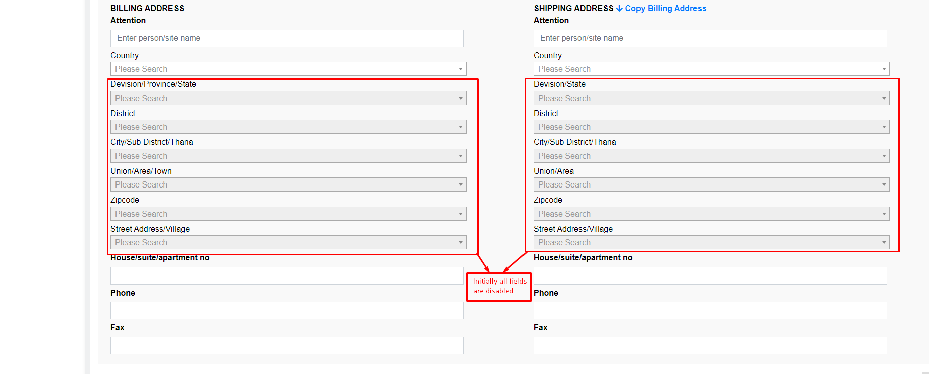

1. *When* ***country*** *is selected then state dropdown will be enable and show all* ***state/division*** *for that specific country*

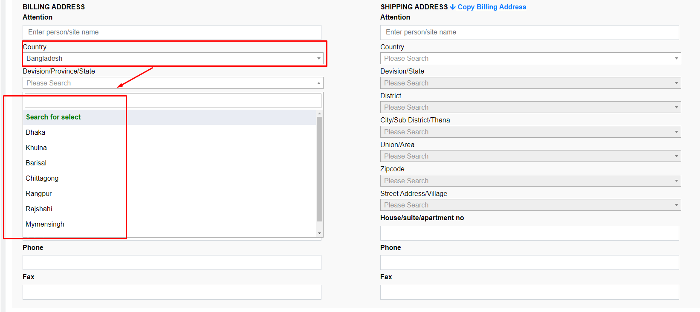

1. *When any* ***state/division*** *is selected then distric dropdown will be enable and show all* ***distric*** *for that specific state/division*

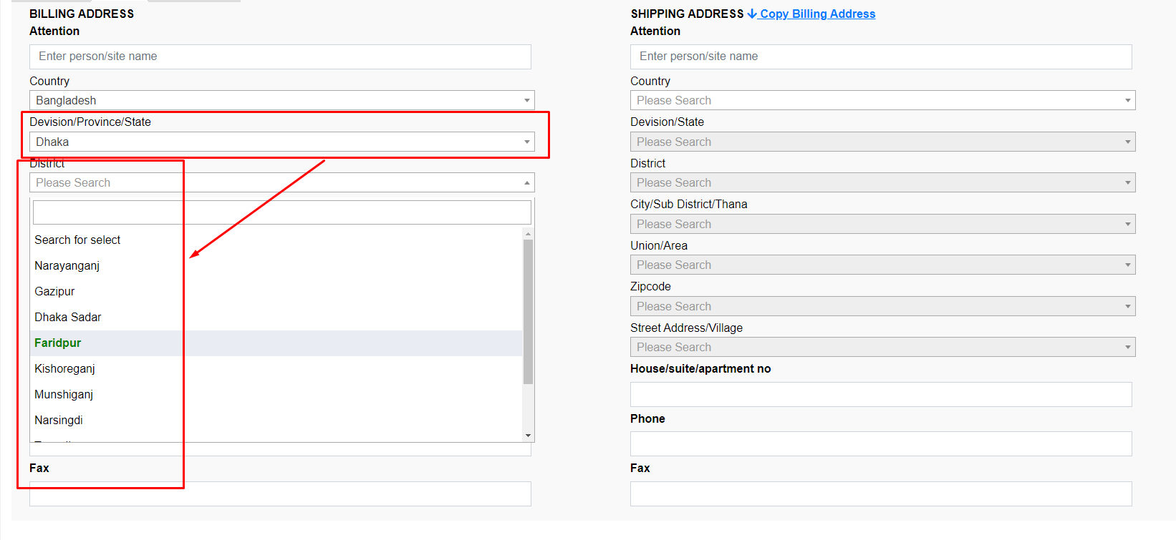

1. *And same will be happened for* ***City/Sub District/Thana, Union/Area/Town , zipcode and Street Address/Village***
2. ***When click on “Copy Billing Address” then save address should come in shipping address section***

*So there are 7 steps relational data you need to create and implement this logic with UI.*

*[N.B.*

*\*\* All dropdown will be autocomplete searchable*

*\*\* You cannot use any third party library for the dropdown behaviour only html, css, javascript & React JS*

*\*\* You need to prepare necessary data to implement that logic.*

*\*\* For more understand please see the video file and let us know if you have any questions.*

**Please send full source code, as we need to check coding standard and other stuff.**

Have a nice day!

If you have any question reply on email.